**LABORATORY MANUAL  
Computer Science Department­**



for the complete fulfillment of the requirements for the lab course of

**Web Engineering**

Submitted by

**STUDENT NAME | CMS ID**

Lab Instructor

Arbab Sufyan

Lecturer, Department of Computer Science,  
Faculty of Information & Communication Technology,   
BUITEMS, Quetta.

**Session Spring – 2022**

TABLE OF CONTENTS

CERTIFICATE iii

LIST OF EXPERIMENTS iv

DOCUMENT VERSION DETAILS v

LAB NO. 1 30/11/2020 1

HTML Paragraph and Text Formatting 1

Lab outcomes: 1

Theory: 1

Equipment: 1

Procedure/ Lab Tasks: 1

[Task1]. HTML Page Paragraphs using <p> tag 2

[Task2]. HTML Heading using <h1>,<h2>,…<h6> tags 2

[Task3]. HTML Line Breaks tags 3

[Task4]. HTML <pre> Element 4

Observations: 6

Rubrics 7

# CERTIFICATE

This is certified that Mr./Miss. **Write Your Name Here** bearing CMS ID # **Write Your CMS ID** has successfully completed the laboratory manual of Web Engineering in his/her 6th semester of BS (Computer Science), Batch Fall-2020 under the supervision of his/her lab instructor Arbab Sufyan.

**_________________ __________________  
Lab Manual Marks Instructor Signature**

# LIST OF EXPERIMENTS

|  |  |
| --- | --- |
| **Sr. No** | **Experiments** |
| **1** | HTML Paragraph and Text Formatting |
| **2** |  |
| **3** |  |
| **4** |  |
| **5** |  |
| **6** |  |
| **7** |  |
| **8** |  |
| **9** |  |
| **10** |  |
| **11** |  |
| **12** |  |
| **13** |  |
| **14** |  |
| **15** |  |
| **16** |  |
| **17** |  |
| **18** |  |
| **19** |  |
| **20** |  |

Note: The above list of experiments is common for this subject in all concerned departments of FICT, however subject instructor shall choose the relevant experiments among this list according to the program requirements.

# DOCUMENT VERSION DETAILS

|  |  |  |  |
| --- | --- | --- | --- |
| **Version** | **Date** | **Author** | **Rationale** |
| **1.0** |  |  |  |
| **1.1** |  |  |  |
| **1.2** |  |  |  |
| **1.3** |  |  |  |
| **1.4** |  |  |  |

# LAB NO. 1 30/11/2020

# HTML Paragraph and Text Formatting

## Lab outcomes:

After completing this lab, students will be able to;

* To create a basic html document
* Learn HTML tags

## Theory:

In this lab students are given basic introduction to HTML and basic html elements, such as Headings and Paragraph, etc., and their properties that how to use them. Students will be exposed to, how an html document is created and what are the results of different html elements. Students will be given an opportunity to create simple portfolio html document.

## Equipment:

* Personal Computer
* Notepad++

## Procedure/ Lab Tasks:

1. All HTML documents must start with a document type declaration: <!DOCTYPE html>.
2. The HTML document itself begins with <html> and ends with </html>.
3. The visible part of the HTML document is between <body> and </body>.

* Try This

<!DOCTYPE html>

<html>

<head>

<title>Page Title</title>

</head>

<body>

<h1>My First Heading</h1>

<p>My first paragraph.</p>

</body>

</html>

|  |
| --- |
|  |

## [Task1]. HTML Page Paragraphs using <p> tag

1. Use the Windows Notepad++ to type the following html code and save it in a file named

“testing_html.html”.

1. Store this file into your machine
2. To edit the file using Notepad++, right click on the file icon and choose “Edit with Notepad++”.
3. Write the next tags in your file:

* Try This

<html>

<body>

<p>Welcome to Web Lab.</p>

<p>Sixth Semester 2022.</p>

<p>Instructor Arbab Sufyan.</p>

</body>

</html>

|  |
| --- |
|  |

## [Task2]. HTML Heading using <h1>,<h2>,…<h6> tags

1. HTML headings are defined with the <h1> to <h6> tags.
2. <h1> defines the most important heading. <h6> defines the least important heading, try this code:

<!DOCTYPE html>

<html>

<body>

<h1>Heading 1</h1>

<h2>Heading 2</h2>

<h3>Heading 3</h3>

<h4>Heading 4</h4>

<h5>Heading 5</h5>

<h6>Heading 6</h6>

</body>

</html>

|  |
| --- |
|  |

## [Task3]. HTML Line Breaks tags

1. The HTML <br> element defines a line break.
2. The <br> tag is an empty tag, which means that it has no end tag.
3. Use <br> if you want a line break (a new line) without starting a new paragraph, try next code:

<!DOCTYPE html>

<html>

<body>

<p>This is<br>a paragraph<br>with line breaks.</p>

</body>

</html>

|  |
| --- |
|  |

## [Task4]. HTML <pre> Element

1. The HTML <pre> element defines preformatted text.
2. The text inside a <pre> element is displayed in a fixed-width font (usually Courier), and it preserves both spaces and line breaks:

<!DOCTYPE html>

<html>

<body>

<p>The pre tag preserves both spaces and line breaks:</p>

<pre>

My Bonnie lies over the ocean.

My Bonnie lies over the sea.

My Bonnie lies over the ocean.

Oh, bring back my Bonnie to me.

</pre>

</body>

</html>

|  |
| --- |
|  |

**[Task5]. HTML Formatting Elements**

1. HTML uses elements like <b> and <i> for formatting output, like bold or italic text.
2. Formatting elements were designed to display special types of text:

* <b> - Bold text
* <i> - Italic text
* <u> - underlined text
* <strike>-strike through over text
* <sub> - Subscript text
* <sup> - Superscript text

<!DOCTYPE html>

<html>

<body>

<p>This text is normal.</p>

<p><b>This text is bold.</b></p>

<p><i>This text is italic</i></p>

<p>This is <sub>subscripted</sub> text.</p>

<p>This is <sup>superscripted</sup> text.</p>

<p>This is a <u>parragraph</u>.</p>

<p>Version2.0 is <strike>not yet available!</strike> </p>

<p> <b><i>This text is bold and italic</i></b></p>

</body>

</html>

|  |
| --- |
|  |

**[Task6]. HTML <hr> Tag**

Use the <hr> tag to draw horizontal line. Try the next code:

<!DOCTYPE html>

<html>

<body>

<h1>HTML</h1>

<p>HTML is a language for describing web pages.</p>

<hr>

<h1>CSS</h1>

<p>CSS defines how to display HTML elements.</p></body></html>

|  |
| --- |
|  |

**Assignments:**

Write an appropriate code to view the next page.

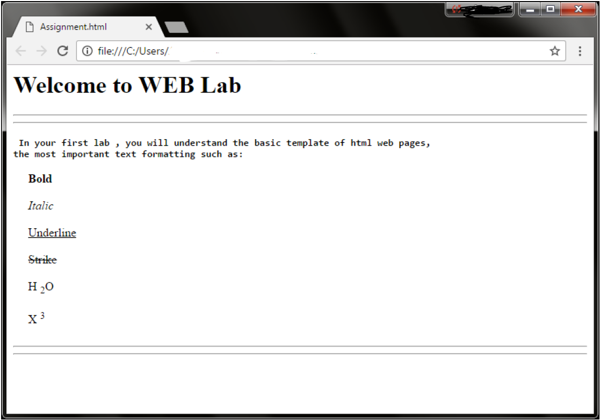

|  |
| --- |
| <html lang="en">  <head>      <meta charset="UTF-8">      <meta http-equiv="X-UA-Compatible" content="IE=edge">      <meta name="viewport" content="width=device-width, initial-scale=1.0">      <title>First Lab created in HTML</title>  </head>  <body>      <h1>Welcome to Web Lab</h1>      <hr>      <hr>  <p>in your firstlab, you will understand the basic template fo html web pages, the most important text formatting such as:</p>  <p><b>Bold</b></p>  <p><i>Italic</i></p>  <p><u>Underline</u></p>  <p><strike>Strike</strike></p>  <p>H<sub>2</sub>O</p>  <p>X<sup>3</sup></p>  <hr>  <hr>  </body>  </html> |

## Observations:

My observation while performing this lab was. I learn about new tags in html that how to bold the text, italic the text, underline, strike, sub and sup and the last HR tag for the horizontal row line

## Rubrics

|  |  |  |  |  |  |  |
| --- | --- | --- | --- | --- | --- | --- |
| **Demonstration** | Absent | Student is unable to follow the provided instructions properly.  The student can name the hardware or simulation platform, but unable to implement anything practically or on the software | Student can understand the provided laboratory instructions and familiar with the lab environment (Trainer/ software/ IDE), but cannot implement on the platform practically or on the software | Student has followed instructions to construct the fundamental schematic/ block diagram/ code/ model on the protoboard/ trainer/ simulation software. | Student has constructed the functional/ working schematic/ model/ block diagram/ code, and have successfully executed the program/ run circuit on software platform | Student perfectly implemented a working model/ logic/ circuit/ block diagram/ code and successfully executed the lab objective in Realtime or in a simulation environment and produced the desired results |
| **Category** | ***Ungraded*** | **Very Poor** | **Poor** | **Fair** | **Good** | **Excellent** |
| **Percentage** | [0] | [1-20] | [21-40] | [41-60] | [61-80] | [81-100] |
| **Marks** | 0.0 | 0.01 - 0.20 | 0.21 - 0.40 | 0.41 - 0.60 | 0.61 - 0.80 | 0.81 - 1.0 |
| **Date** |  | **Total Marks** |  | **Instructor’s Signature** | |  |

|  |  |  |  |  |  |  |
| --- | --- | --- | --- | --- | --- | --- |
| **Laboratory Reports** | Report not submitted | Plagiarized content presented or incomplete submission | Requirements are listed and experimental procedure is presented | Observations are recorded along with detailed procedure | Appropriate computations or numerical analysis is performed | Correctly drawn conclusion with  exact results and complete report in all respects |
| **Category** | ***Ungraded*** | **Very Poor** | **Poor** | **Fair** | **Good** | **Excellent** |
| **Percentage** | [0] | [1-20] | [21-40] | [41-60] | [61-80] | [81-100] |
| **Marks** | 0.0 | 0.01 - 0.20 | 0.21 - 0.40 | 0.41 - 0.60 | 0.61 - 0.80 | 0.81 - 1.0 |
| **Date** |  | **Total Marks** |  | **Instructor’s Signature** | |  |

# LAB NO. 2 24/05/2022

# HTML Lists and Images

## Lab outcomes:

After completing this lab, students will be able to;

1. Inserting Images into a Web Page
   1. Image src attribute.
   2. Other img Element Attributes (alt, width and height attributes.)
2. Creating Lists
   1. Ordered Lists
   2. Unordered Lists
   3. Definition Lists
   4. Nesting Lists

## Equipment:

* Personal Computer
* Notepad++

## Lab Tasks:

## Working with Images

In HTML, images (Gif,JPG, PNG) are defined with the <img> tag.The <img> tag is empty, it contains attributes only, and does not have a closing tag. The src attribute specifies the URL of the image:

**General:** <img src="url" alt="some_text" width="width "height="height">

## [Task1]. Display images from the same folder of the web page

|  |
| --- |
| <html lang="en">  <head>      <meta charset="UTF-8">      <meta http-equiv="X-UA-Compatible" content="IE=edge">      <meta name="viewport" content="width=device-width, initial-scale=1.0">      <title>Document</title>  </head>  <body>      <img src="d.png" alt="the png picture is taken form the same folder">    </body>  </html> |

## [Task2]. Display images from another folder of the web page

|  |
| --- |
| <!DOCTYPE html>  <body>  <img src=file:///C:/Users/sony/Downloads/Komi-San.jpg   alt=”this image is taken from the c drive of my computer”">  </body>  RESULTS: |

## [Task3]. Image alt, width and height attributes

* The alt attribute provides an alternate text for an image, if the user for some reason cannot view it.
* You can use the width and height attributes to specify the width and height of an image in pixels.

|  |
| --- |
| <!DOCTYPE html>  <body>  <img src="sakuna.jpg" alt=" pic of sakuna an anime '" width="400" height="400">  </body> |

## Adding Lists to a Web Page

## [Task4]. The ordered list in HTML

The ordered list which is created by the ol Element that begins with the <ol> tag and ends with a

closing </ol> tag. The attributes required: type attribute and the start attribute.

|  |
| --- |
| <!DOCTYPE html>  <body>  <ol>  <li>Number 1</li>  <li>Number 2</li>  <li>Number 3</li>  <li>Number 4</li>  <li>Number 5</li>  </ol>  </body> |

## Type Attribute can take one of the next values:

|  |  |
| --- | --- |
| Type | Description |
| type="1" | The list items will be numbered with numbers (default) |
| type="A" | The list items will be numbered with uppercase letters |
| type="a" | The list items will be numbered with lowercase letters |
| type="I" | The list items will be numbered with uppercase roman numbers |
| type="i" | The list items will be numbered with lowercase roman numbers |

**Numbers:**

<ol type="1">

<li>Coffee</li>

<li>Tea</li>

<li>Milk</li>

</ol>

**Uppercase Letters:**

<ol type="A">

<li>Coffee</li>

<li>Tea</li>

<li>Milk</li>

</ol>

**Lowercase Letters:**

<ol type="a">

<li>Coffee</li>

<li>Tea</li>

<li>Milk</li>

</ol>

**Uppercase Roman Numbers:**

<ol type="I">

<li>Coffee</li>

<li>Tea</li>

<li>Milk</li>

</ol>

**Lowercase Roman Numbers:**

<ol type="i">

<li>Coffee</li>

<li>Tea</li>

<li>Milk</li>

</ol>

## [Task5]. <ol> start Attribute: define the start value of the list.

|  |
| --- |
| <!DOCTYPE html>  <body>  <ol type="i">  <li>ABC</li>  <li>IJK</li>  <li>XYZ</li>  </ol>  </body> |

## [Task6]. Unordered list in HTML

The unordered list which is created by the ul Element that begins with the <ul> tag and ends with </ul>. The attributes required: just the type attribute.

|  |
| --- |
| <!DOCTYPE html>  <body>  <ul>  <li>Number 1</li>  <li>Number 2</li>  <li>Number 3</li>  </ul>  </body> |

**In unordered list, Type Attribute can take one of the next values:**

**Disc:**

<ul type="disc">

<li>Coffee</li>

<li>Tea</li>

<li>Milk</li>

</ul>

**Circle:**

<ul type="circle">

<li>Coffee</li>

<li>Tea</li>

<li>Milk</li>

</ul>

**Square:**

<ul type="square">

<li>Coffee</li>

<li>Tea</li>

<li>Milk</li>

</ul>

**None:**

<ul type="none">

<li>Coffee</li>

<li>Tea</li>

<li>Milk</li>

</ul>

## [Task7]. Write the code for the following nested list

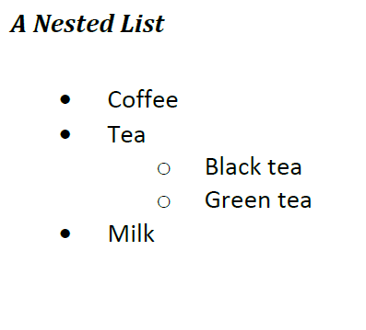

|  |
| --- |
| <!DOCTYPE html>  <body>  <ul>  <li>Coffee</li>  <li>Tea  <ul>  <li>Black tea</li>  <li>Green tea</li>  </ul>  </li>  <li>Milk</li>  </ul>  </body> |

## Assignments:

Write the required code to create the following output:

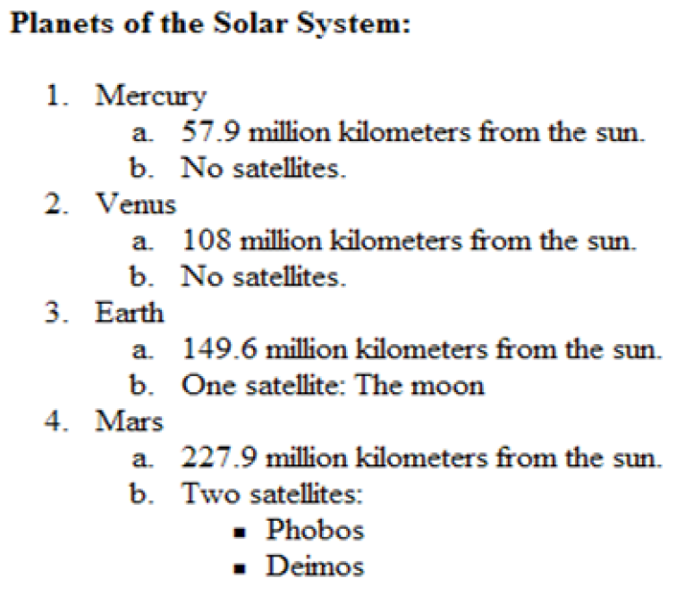

|  |
| --- |
| <!DOCTYPE html>  <html>  <body>  <ol>  <li>Mercury</li>  <ol type="a">  <li>57.9 million kilometer away from Sun</li>  <li>No Satellites</li>  </ol>  <li>Venus</li>  <ol type="a">  <li>108 million kilometer away from Sun</li>  <li>No Satellites</li>  </ol>  </li>  <li>Earth</li>  <ol type="a">  <li>149.6 million kilometer away from Sun</li>  <li>One Satellite: The Moon</li>  </ol>  <li>Mars</li>  <ol type="a">  <li>227.9 million kilometer away from Sun</li>  <li>Two Satellites:</li>  <ul>  <li>Phobos<li>  <li>Deimos<li>  </ul>  </ol>  </ol>  </body>  </html> |

## Observations:

Please write your observation after conducting this lab, you have to write in few lines, what did you learn in this lab

## Rubrics

|  |  |  |  |  |  |  |
| --- | --- | --- | --- | --- | --- | --- |
| **Demonstration** | Absent | Student is unable to follow the provided instructions properly.  The student can name the hardware or simulation platform, but unable to implement anything practically or on the software | Student can understand the provided laboratory instructions and familiar with the lab environment (Trainer/ software/ IDE), but cannot implement on the platform practically or on the software | Student has followed instructions to construct the fundamental schematic/ block diagram/ code/ model on the protoboard/ trainer/ simulation software. | Student has constructed the functional/ working schematic/ model/ block diagram/ code, and have successfully executed the program/ run circuit on software platform | Student perfectly implemented a working model/ logic/ circuit/ block diagram/ code and successfully executed the lab objective in Realtime or in a simulation environment and produced the desired results |
| **Category** | ***Ungraded*** | **Very Poor** | **Poor** | **Fair** | **Good** | **Excellent** |
| **Percentage** | [0] | [1-20] | [21-40] | [41-60] | [61-80] | [81-100] |
| **Marks** | 0.0 | 0.01 - 0.20 | 0.21 - 0.40 | 0.41 - 0.60 | 0.61 - 0.80 | 0.81 - 1.0 |
| **Date** |  | **Total Marks** |  | **Instructor’s Signature** | |  |

|  |  |  |  |  |  |  |
| --- | --- | --- | --- | --- | --- | --- |
| **Laboratory Reports** | Report not submitted | Plagiarized content presented or incomplete submission | Requirements are listed and experimental procedure is presented | Observations are recorded along with detailed procedure | Appropriate computations or numerical analysis is performed | Correctly drawn conclusion with  exact results and complete report in all respects |
| **Category** | ***Ungraded*** | **Very Poor** | **Poor** | **Fair** | **Good** | **Excellent** |
| **Percentage** | [0] | [1-20] | [21-40] | [41-60] | [61-80] | [81-100] |
| **Marks** | 0.0 | 0.01 - 0.20 | 0.21 - 0.40 | 0.41 - 0.60 | 0.61 - 0.80 | 0.81 - 1.0 |
| **Date** |  | **Total Marks** |  | **Instructor’s Signature** | |  |

# LAB NO. 3 21/05/2022

# CSS and HTML Forms

## Lab outcomes:

* The intent of this Lab is to demonstrate your mastery of HTML and CSS.

## Equipment:

* Personal Computer
* Notepad++

## Theory

You must create the two HTML web pages shown below. You must use CSS for formatting; however, other than some floats, CSS positioning will not be necessary. The page does not have to be an exact match; it should however be as close as possible and look the same on the major browsers.

The two link menus must be lists with different hover behavior. For the dummy links, make the destination URL “#”.

Both pages must use the same single CSS file.

## Lab Tasks:

## [Task1] Page One

1. This file must be named pageOne.html.
2. It must use CSS floats to implement the side-by-side layouts



|  |
| --- |
| Write your results here, each picture must be captioned and centralized |

[Task2]. ***Page Two***

1. This file must be named pageTwo.html.
2. It must use a table to layout the form elements.
3. Use the correct form element types. Remember that some of the HTML5 elements look different in different browsers. (The screen captures are from Chrome).
4. While I don’t expect your form to look exactly like mine, it should be close.

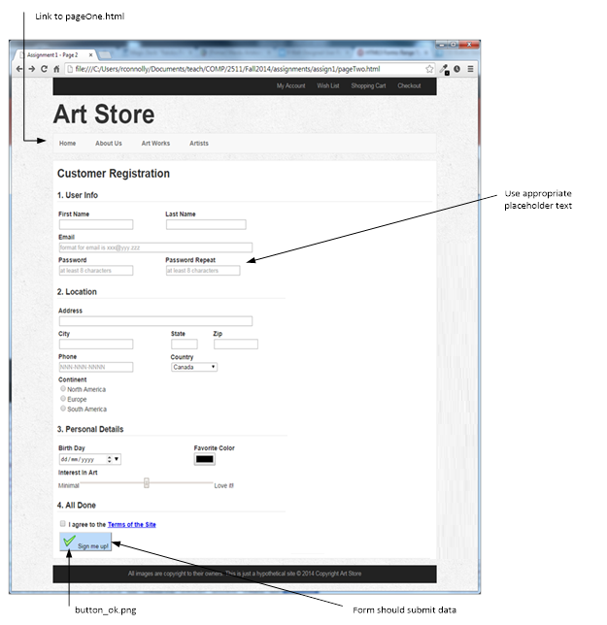

|  |
| --- |
| Write your results here, each picture must be captioned and centralized |

## Observations:

Please write your observation after conducting this lab, you have to write in few lines, what did you learn in this lab

## Rubrics

|  |  |  |  |  |  |  |
| --- | --- | --- | --- | --- | --- | --- |
| **Demonstration** | Absent | Student is unable to follow the provided instructions properly.  The student can name the hardware or simulation platform, but unable to implement anything practically or on the software | Student can understand the provided laboratory instructions and familiar with the lab environment (Trainer/ software/ IDE), but cannot implement on the platform practically or on the software | Student has followed instructions to construct the fundamental schematic/ block diagram/ code/ model on the protoboard/ trainer/ simulation software. | Student has constructed the functional/ working schematic/ model/ block diagram/ code, and have successfully executed the program/ run circuit on software platform | Student perfectly implemented a working model/ logic/ circuit/ block diagram/ code and successfully executed the lab objective in Realtime or in a simulation environment and produced the desired results |
| **Category** | ***Ungraded*** | **Very Poor** | **Poor** | **Fair** | **Good** | **Excellent** |
| **Percentage** | [0] | [1-20] | [21-40] | [41-60] | [61-80] | [81-100] |
| **Marks** | 0.0 | 0.01 - 0.20 | 0.21 - 0.40 | 0.41 - 0.60 | 0.61 - 0.80 | 0.81 - 1.0 |
| **Date** |  | **Total Marks** |  | **Instructor’s Signature** | |  |

|  |  |  |  |  |  |  |
| --- | --- | --- | --- | --- | --- | --- |
| **Laboratory Reports** | Report not submitted | Plagiarized content presented or incomplete submission | Requirements are listed and experimental procedure is presented | Observations are recorded along with detailed procedure | Appropriate computations or numerical analysis is performed | Correctly drawn conclusion with  exact results and complete report in all respects |
| **Category** | ***Ungraded*** | **Very Poor** | **Poor** | **Fair** | **Good** | **Excellent** |
| **Percentage** | [0] | [1-20] | [21-40] | [41-60] | [61-80] | [81-100] |
| **Marks** | 0.0 | 0.01 - 0.20 | 0.21 - 0.40 | 0.41 - 0.60 | 0.61 - 0.80 | 0.81 - 1.0 |
| **Date** |  | **Total Marks** |  | **Instructor’s Signature** | |  |

# LAB NO. 4 27/05/2022

# HTML Tables

## Lab outcomes:

* The intent of this Lab is to demonstrate your mastery of HTML Tables.
* Creating HTML Tables
* Learn the different attributes of tables such as: caption, colspan, rowspan and others.

## Equipment:

* Personal Computer
* Notepad++

## Theory

An HTML table is defined with the **<table>** tag. Each table row is defined with the **<tr>** tag. A table header is defined with the **<th>** tag. By default, table headings are bold and centered. A table data/cell is defined with the **<td>** tag.

|  |
| --- |
| <table>  <tr>  <th>Firstname</th>  <th>Lastname</th>  <th>Age</th>  </tr>  <tr>  <td>Asma</td>  <td>Mohammad</td>  <td>33</td>  </tr>  <tr>  <td>Ahmad</td>  <td>Naji</td>  <td>46</td>  </tr>  </table> |

**Note:** The <td> elements are the data containers of the table.

They can contain all sorts of HTML elements; text, images, lists, other tables, etc.

## Lab Tasks:

## [Task1] Double Border Table, Coloring and width

|  |
| --- |
| <html>  <head>  <style>  table, th, td { border: solid;  border-width: 3px;  border-color : red;}  th { color : green;}  td { color : blue;}  </style>  </head>  <body>  <table>  <tr>  <th>Firstname</th>  <th>Lastname</th>  <th>Age</th>  </tr>  <tr>  <td>Muhammad</td>  <td>Haseeb</td>  <td>21</td>  </tr>  <tr>  <td>Ahmad</td>  <td>Gul</td>  <td>20</td>  </tr>  <tr>  <td>Nazir</td>  <td>Shah</td>  <td>18</td>  </tr>  <tr>  <td>Saad</td>  <td>Ahmed</td>  <td>22</td>  </tr>  <tr>  <td>Hassan</td>  <td>Ali</td>  <td>23</td>  </tr>  </body>  </html |

## [Task2]. Single Border Table

|  |
| --- |
| Ex. <head>  <style> table, th, td {  border: solid ;  border-collapse: collapse; //single line border  border-width: 3px;  border-color : red;}  th { color : green;} **td { color : blue;} </style> </head>** <html lang="en">    <head>  <style> table, th, td {  border: solid ;  border-collapse: collapse;  border-width: 2 px;  border-color : blue;}  th { color : grey;}  td { color : red;} </style>  </head>    <body>    <table style="width:70%">  <tr>  <th>Car</th>  <th>Company</th>  <th>Horse Power</th>  </tr>  <tr>  <td>GT-R Skyline</td>  <td>Nissan</td>  <td>1200</td>  </tr>  <tr>  <td>Supra</td>  <td>Tpota</td>  <td>1400</td>  </tr>  <tr>  <td>RX-7</td>  <td>Mazda</td>  <td>900</td>  </tr>  </table>      </body>  </html> |

## Task 3 Table Cell Padding and cell spacing

Cell padding specifies the space between the cell content and its borders.

✓ The cellspacing attribute specifies the space, in pixels, between cells.

|  |
| --- |
| <!DOCTYPE html>  <html>  <head>  <style>  table, th, td {  border: 1px solid black;  border-collapse: collapse;  }  th, td {  padding: 10px;  }  </style>  </head>  <body>  <table style="width:70%">  <tr>  <th>Car</th>  <th>Company</th>  <th>Horse Power</th>  </tr>  <tr>  <td>GT-R Skyline</td>  <td>Nissan</td>  <td>1200</td>  </tr>  <tr>  <td>Supra</td>  <td>Tpota</td>  <td>1400</td>  </tr>  <tr>  <td>RX-7</td>  <td>Mazda</td>  <td>900</td>  </tr>  </table>  </body>  </html> |

## Task 4 Align Attribute

The align attribute specifies the **horizontal** alignment of the content in a cell.

|  |
| --- |
| <!DOCTYPE html>  <html>  <head>  <style>  table, th, td {  border: 1px solid black;  border-collapse: collapse;  }  th, td {  padding: 10px;  }  </style>  </head>  <body>  <table style="width:70%">  <tr>  <th>Car</th>  <th>Company</th>  <th>Horse Power</th>  </tr>  <tr>  <td align = "right">GT-R Skyline</td>  <td>Nissan</td>  <td align = "right"> 1200</td>  </tr>  <tr>  <td>Supra</td>  <td>Toyota</td>  <td>1400</td>  </tr>  <tr>  <td align = "right">RX-7</td>  <td>Mazda</td>  <td align = "right">900</td>  </tr>  </table>  </body>  </html> |

## Task 6 Write the required code to create the following output:

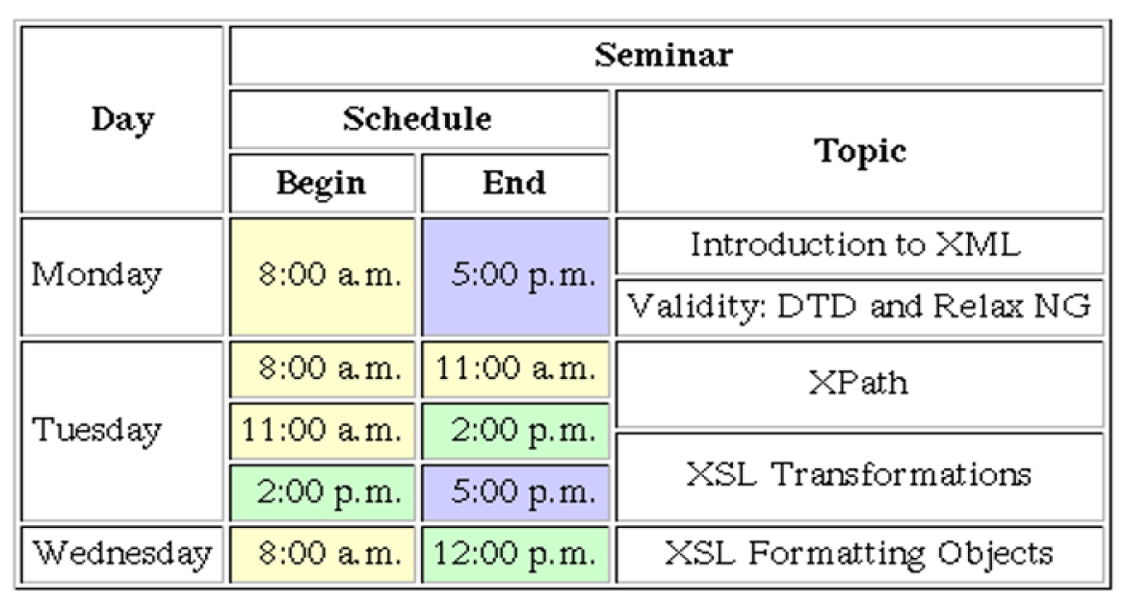

|  |
| --- |
| <style>  table, th, td {  border: 1px solid black;  border-collapse: collapse;  }  th, td {  padding: 10px;  }  </style>  <table>  <thead>  <tr>  <th colspan="3"; align = "left"; padding = "70%">  Day  </th>  <th>Seminar  </tr>  <tr>  <td colspan="2" ; spacing = "30%">  <br> Monday  </td>  <td colspan="2" ; spacing = "30%">  <br> Schedule  </td>  <td colspan="2"> Topic  </td>  </tr>  </thead>  <tbody>  <tr>  <th>Tuesday</th>  <td colspan="2"> Starts  </td>  <td colspan="2"> End  </td>  </th>  </tr>  <tr>  <td>wednesday  </td>  <td>8:00 am</td>  <td colspan = " 2">5:00 pm</td>  <td>Intro to XML</td>  </tr>  <tr>  <td>Thursday</td>  <td>11:00 am</td>  <td colspan = "2 ">4:00 pm</td>  <td>XSL Formatting Objects<td>  </tr>  </tbody>  <tfoot>  </tfoot>  </table> |

## Observations:

Please write your observation after conducting this lab, you have to write in few lines, what did you learn in this lab

## Rubrics

|  |  |  |  |  |  |  |
| --- | --- | --- | --- | --- | --- | --- |
| **Demonstration** | Absent | Student is unable to follow the provided instructions properly.  The student can name the hardware or simulation platform, but unable to implement anything practically or on the software | Student can understand the provided laboratory instructions and familiar with the lab environment (Trainer/ software/ IDE), but cannot implement on the platform practically or on the software | Student has followed instructions to construct the fundamental schematic/ block diagram/ code/ model on the protoboard/ trainer/ simulation software. | Student has constructed the functional/ working schematic/ model/ block diagram/ code, and have successfully executed the program/ run circuit on software platform | Student perfectly implemented a working model/ logic/ circuit/ block diagram/ code and successfully executed the lab objective in Realtime or in a simulation environment and produced the desired results |
| **Category** | ***Ungraded*** | **Very Poor** | **Poor** | **Fair** | **Good** | **Excellent** |
| **Percentage** | [0] | [1-20] | [21-40] | [41-60] | [61-80] | [81-100] |
| **Marks** | 0.0 | 0.01 - 0.20 | 0.21 - 0.40 | 0.41 - 0.60 | 0.61 - 0.80 | 0.81 - 1.0 |
| **Date** |  | **Total Marks** |  | **Instructor’s Signature** | |  |

|  |  |  |  |  |  |  |
| --- | --- | --- | --- | --- | --- | --- |
| **Laboratory Reports** | Report not submitted | Plagiarized content presented or incomplete submission | Requirements are listed and experimental procedure is presented | Observations are recorded along with detailed procedure | Appropriate computations or numerical analysis is performed | Correctly drawn conclusion with  exact results and complete report in all respects |
| **Category** | ***Ungraded*** | **Very Poor** | **Poor** | **Fair** | **Good** | **Excellent** |
| **Percentage** | [0] | [1-20] | [21-40] | [41-60] | [61-80] | [81-100] |
| **Marks** | 0.0 | 0.01 - 0.20 | 0.21 - 0.40 | 0.41 - 0.60 | 0.61 - 0.80 | 0.81 - 1.0 |
| **Date** |  | **Total Marks** |  | **Instructor’s Signature** | |  |

# LAB NO. 5 19/06/2022

# Client side and server side controls and field validation

## Lab outcomes:

* The intent of this Lab is to differentiate between client side and server side controls.
* Write JavaScript code to validate fields
* Write Server side code to validate Fields

## Equipment:

* Personal Computer
* Visual Studio ASP.Net Core

## Theory

From a conceptual point of view all controls can be classified into two big categories: Client Controls and Server Controls. Client Controls are bound to client side JavaScript data and create their Html dynamically on the client side, while Html of Server Controls are rendered on the server side using data contained in a server side ViewModel.

The main advantages of server controls are:

1. Their “static” Html is visible to the search engines,
2. They require less “job” on the client side so they are efficiently rendered also by low performance browsers (such as the browsers of low quality mobile devices).

On the other side client controls offer:

1. More flexibility, and a better interaction with all other html elements of the page, which, in turn, implies a richer user experience,
2. Less round-trips to the server, and a lower bandwidth consumption since less data are exchanged with the server less frequently.

## Lab Tasks:

## [Task1] Client Side controls

1. Create a new ASP.Net project
2. Create a new Webpage and name it as **client side**.
3. Design webpage as shown below and make sure you use only client side html Controls in your page.
4. After designing the page use JavaScript code to validate fields information as follow.
   1. First name and last name should not contain special character or number.
   2. Male or Female must be choosen.
   3. Date of birth must be selected.

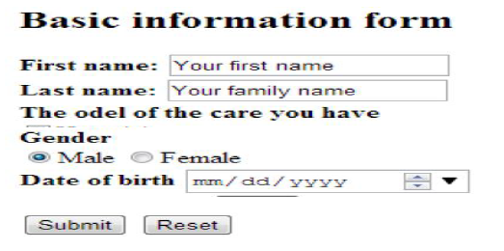

|  |
| --- |
| Write your results here, each picture must be captioned and centralized |

## [Task2]. Server side controls

1. Create a new Webpage and name it as **Server Side**.
2. Design webpage as shown below and make sure you use only Server side Controls in your page.
3. After designing the page use server side code (C#) to validate fields information as follows.
   1. First name, Surname and Father name should not contain special character or number.
   2. Gender must be selected.
   3. Date of birth must be selected
   4. Course must be selected.
   5. Address must be typed.
   6. Phone number must be written.

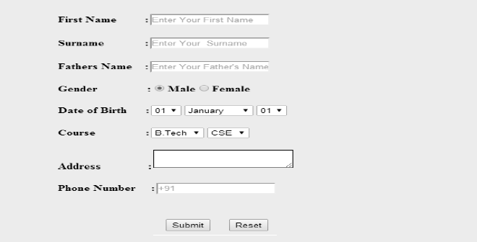

|  |
| --- |
| Write your results here, each picture must be captioned and centralized |

## Observations:

Please write your observation after conducting this lab, you have to write in few lines, what did you learn in this lab

## Rubrics

|  |  |  |  |  |  |  |
| --- | --- | --- | --- | --- | --- | --- |
| **Demonstration** | Absent | Student is unable to follow the provided instructions properly.  The student can name the hardware or simulation platform, but unable to implement anything practically or on the software | Student can understand the provided laboratory instructions and familiar with the lab environment (Trainer/ software/ IDE), but cannot implement on the platform practically or on the software | Student has followed instructions to construct the fundamental schematic/ block diagram/ code/ model on the protoboard/ trainer/ simulation software. | Student has constructed the functional/ working schematic/ model/ block diagram/ code, and have successfully executed the program/ run circuit on software platform | Student perfectly implemented a working model/ logic/ circuit/ block diagram/ code and successfully executed the lab objective in Realtime or in a simulation environment and produced the desired results |
| **Category** | ***Ungraded*** | **Very Poor** | **Poor** | **Fair** | **Good** | **Excellent** |
| **Percentage** | [0] | [1-20] | [21-40] | [41-60] | [61-80] | [81-100] |
| **Marks** | 0.0 | 0.01 - 0.20 | 0.21 - 0.40 | 0.41 - 0.60 | 0.61 - 0.80 | 0.81 - 1.0 |
| **Date** |  | **Total Marks** |  | **Instructor’s Signature** | |  |

|  |  |  |  |  |  |  |
| --- | --- | --- | --- | --- | --- | --- |
| **Laboratory Reports** | Report not submitted | Plagiarized content presented or incomplete submission | Requirements are listed and experimental procedure is presented | Observations are recorded along with detailed procedure | Appropriate computations or numerical analysis is performed | Correctly drawn conclusion with  exact results and complete report in all respects |
| **Category** | ***Ungraded*** | **Very Poor** | **Poor** | **Fair** | **Good** | **Excellent** |
| **Percentage** | [0] | [1-20] | [21-40] | [41-60] | [61-80] | [81-100] |
| **Marks** | 0.0 | 0.01 - 0.20 | 0.21 - 0.40 | 0.41 - 0.60 | 0.61 - 0.80 | 0.81 - 1.0 |
| **Date** |  | **Total Marks** |  | **Instructor’s Signature** | |  |

# LAB NO. 6 26/07/2022

# Connecting ASP.Net with SQL Server

## Lab outcomes:

* The intent of this Lab is to learn how to connect SQL database with asp.net.
* Create SQL database in SQL server Management Studio.
* Create a table in database
* Connect database with ASP.Net using ADO.Net

## Equipment:

* Personal Computer
* Visual Studio ASP.Net Core
* SQL Server Management Studio.

## Theory

ADO.NET is the data access component for the .NET Framework.

ADO.NET leverages the power of XML to provide disconnected access to data. ADO.NET is made of a set of classes that are used for connecting to a database, providing access to relational data, XML, and application data, and retrieving results. ADO.NET data providers contain classes that represent the provider's Connection, Command, DataAdapter and DataReader objects (among others).

## Lab Tasks:

## [Task 1] Creating an SQL Database and Table

1. Open SQL Server Management Studio
2. Create a new Database as name it as “**MyDatabase**”.
3. Within “MyDatabase” Database, create a new table with the bellow mentioned fields.

|  |  |
| --- | --- |
| Field Name | Datatype |
| ID | Int (PK) |
| FirstName | Varchar(50) |
| LastName | Varchar(50) |
| Gender | Varchar(10) |
| DOB | Varchar(50) |

1. After Creating table in SQL take a screenshot of the table and paste it into below provided space.

|  |
| --- |
| Write your results here, each picture must be captioned and centralized |

## [Task 2] Connecting ASP.Net using connection string

1. Create a new ASP.Net project
2. Create a new Webpage and name it as **default**.
3. Design webpage as shown below.
4. On submit button click write a code that establishes connection with the “**Mydatabase**” database and prompts message connection successful.

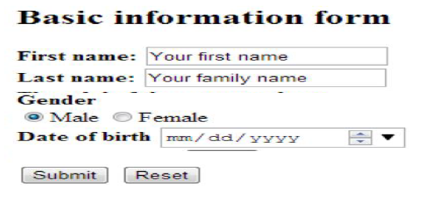

|  |
| --- |
| Write your results here, each picture must be captioned and centralized |

## [Task 3] Inserting record into SQL database

1. After successful completion to the Task 2, write a code on submit button that saves record in database
2. insert the data in to database using Execute-Non Query.
3. Prompt message “One record entered”



|  |
| --- |
| Write your results here, each picture must be captioned and centralized |

## Observations:

Please write your observation after conducting this lab, you have to write in few lines, what did you learn in this lab

## Rubrics

|  |  |  |  |  |  |  |
| --- | --- | --- | --- | --- | --- | --- |
| **Demonstration** | Absent | Student is unable to follow the provided instructions properly.  The student can name the hardware or simulation platform, but unable to implement anything practically or on the software | Student can understand the provided laboratory instructions and familiar with the lab environment (Trainer/ software/ IDE), but cannot implement on the platform practically or on the software | Student has followed instructions to construct the fundamental schematic/ block diagram/ code/ model on the protoboard/ trainer/ simulation software. | Student has constructed the functional/ working schematic/ model/ block diagram/ code, and have successfully executed the program/ run circuit on software platform | Student perfectly implemented a working model/ logic/ circuit/ block diagram/ code and successfully executed the lab objective in Realtime or in a simulation environment and produced the desired results |
| **Category** | ***Ungraded*** | **Very Poor** | **Poor** | **Fair** | **Good** | **Excellent** |
| **Percentage** | [0] | [1-20] | [21-40] | [41-60] | [61-80] | [81-100] |
| **Marks** | 0.0 | 0.01 - 0.20 | 0.21 - 0.40 | 0.41 - 0.60 | 0.61 - 0.80 | 0.81 - 1.0 |
| **Date** |  | **Total Marks** |  | **Instructor’s Signature** | |  |

|  |  |  |  |  |  |  |
| --- | --- | --- | --- | --- | --- | --- |
| **Laboratory Reports** | Report not submitted | Plagiarized content presented or incomplete submission | Requirements are listed and experimental procedure is presented | Observations are recorded along with detailed procedure | Appropriate computations or numerical analysis is performed | Correctly drawn conclusion with  exact results and complete report in all respects |
| **Category** | ***Ungraded*** | **Very Poor** | **Poor** | **Fair** | **Good** | **Excellent** |
| **Percentage** | [0] | [1-20] | [21-40] | [41-60] | [61-80] | [81-100] |
| **Marks** | 0.0 | 0.01 - 0.20 | 0.21 - 0.40 | 0.41 - 0.60 | 0.61 - 0.80 | 0.81 - 1.0 |
| **Date** |  | **Total Marks** |  | **Instructor’s Signature** | |  |

# LAB NO. 8 02/08/2022

# CRUD operations using ASP.Net (Part 1)

## Lab outcomes:

* The intent of this Lab is to learn how to connect SQL database with asp.net.
* Learn how to execute CRUD operations from ASP.NET using ADO.NET

## Equipment:

* Personal Computer
* Visual Studio ASP.Net Core
* SQL Server Management Studio.

## Theory

Within computer programming, the acronym CRUD stands for create, read, update and delete. These are the four basic functions of persistent storage. Also, each letter in the acronym can refer to all functions executed in relational database applications and mapped to a standard HTTP method, SQL statement or DDS operation.

It can [also describe](https://softwareengineering.stackexchange.com/questions/120716/difference-between-rest-and-crud) user-interface conventions that allow viewing, searching and modifying information through computer-based forms and reports. In essence, entities are read, created, updated and deleted. Those same entities can be modified by taking the data from a service and changing the setting properties before sending the data back to the service for an update. Plus, CRUD is data-oriented and the standardized use of HTTP action verbs.

## Lab Tasks:

## [Task 1] Inserting record into SQL database from ASP.Net

1. Create a new ASP.Net project and design the page as depicted in the below figure.
2. Identify the attributes required to create the following table in the database.
3. Write ADO.Net C# code on the submit button to save the record in the database.
4. Prompt message “One record entered”

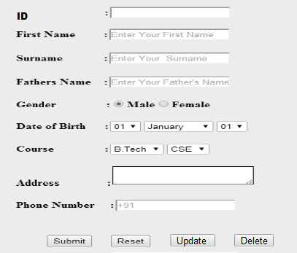

|  |
| --- |
| Write your results here, each picture must be captioned and centralized |

## [Task 2] Updating a record into SQL database from ASP.Net

1. Write ADO.Net C# code on the update button to update the record based on ID.
2. Prompt message “One record updated”

|  |
| --- |
| Write your results here, each picture must be captioned and centralized |

## [Task 3] Deleting a record into SQL database from ASP.Net

1. Write ADO.Net C# code on the delete button to delete the record based on ID.
2. Prompt message “One record deleted”

|  |
| --- |
| Write your results here, each picture must be captioned and centralized |

## Observations:

Please write your observation after conducting this lab, you have to write in few lines, what did you learn in this lab

## Rubrics

|  |  |  |  |  |  |  |
| --- | --- | --- | --- | --- | --- | --- |
| **Demonstration** | Absent | Student is unable to follow the provided instructions properly.  The student can name the hardware or simulation platform, but unable to implement anything practically or on the software | Student can understand the provided laboratory instructions and familiar with the lab environment (Trainer/ software/ IDE), but cannot implement on the platform practically or on the software | Student has followed instructions to construct the fundamental schematic/ block diagram/ code/ model on the protoboard/ trainer/ simulation software. | Student has constructed the functional/ working schematic/ model/ block diagram/ code, and have successfully executed the program/ run circuit on software platform | Student perfectly implemented a working model/ logic/ circuit/ block diagram/ code and successfully executed the lab objective in Realtime or in a simulation environment and produced the desired results |
| **Category** | ***Ungraded*** | **Very Poor** | **Poor** | **Fair** | **Good** | **Excellent** |
| **Percentage** | [0] | [1-20] | [21-40] | [41-60] | [61-80] | [81-100] |
| **Marks** | 0.0 | 0.01 - 0.20 | 0.21 - 0.40 | 0.41 - 0.60 | 0.61 - 0.80 | 0.81 - 1.0 |
| **Date** |  | **Total Marks** |  | **Instructor’s Signature** | |  |

|  |  |  |  |  |  |  |
| --- | --- | --- | --- | --- | --- | --- |
| **Laboratory Reports** | Report not submitted | Plagiarized content presented or incomplete submission | Requirements are listed and experimental procedure is presented | Observations are recorded along with detailed procedure | Appropriate computations or numerical analysis is performed | Correctly drawn conclusion with  exact results and complete report in all respects |
| **Category** | ***Ungraded*** | **Very Poor** | **Poor** | **Fair** | **Good** | **Excellent** |
| **Percentage** | [0] | [1-20] | [21-40] | [41-60] | [61-80] | [81-100] |
| **Marks** | 0.0 | 0.01 - 0.20 | 0.21 - 0.40 | 0.41 - 0.60 | 0.61 - 0.80 | 0.81 - 1.0 |
| **Date** |  | **Total Marks** |  | **Instructor’s Signature** | |  |